**Mass Spring**

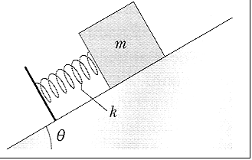

$\left[\begin{matrix}x_{1} \\ x_{2}\end{matrix}\right]$ = $\left[\begin{matrix}x \\ \dot{x}\end{matrix}\right]$

$\left[\begin{matrix}{\dot{x}}_{1} \\ {\dot{x}}_{2}\end{matrix}\right]$ = $\left[\begin{matrix}\dot{x} \\ \ddot{x}\end{matrix}\right]$ = $\left[\begin{matrix}x_{2} \\ \frac{-k}{m}\left(x_{1}-x_{e}\right)-μgcos\left(θ\right)σ\left(x_{2}\right)-gsin\left(θ\right)\end{matrix}\right]$

**Simulink**

parameters

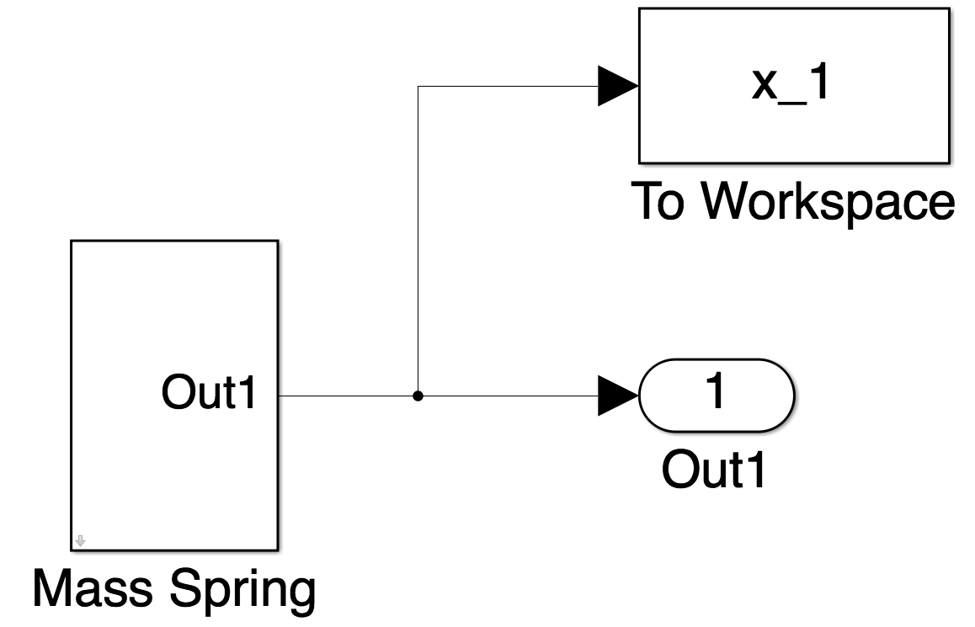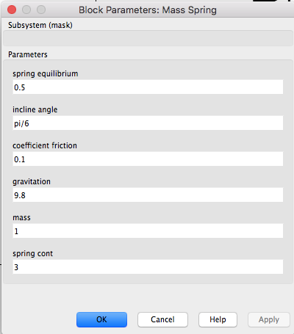

This is Simulink which is the equation of motion of mass spring

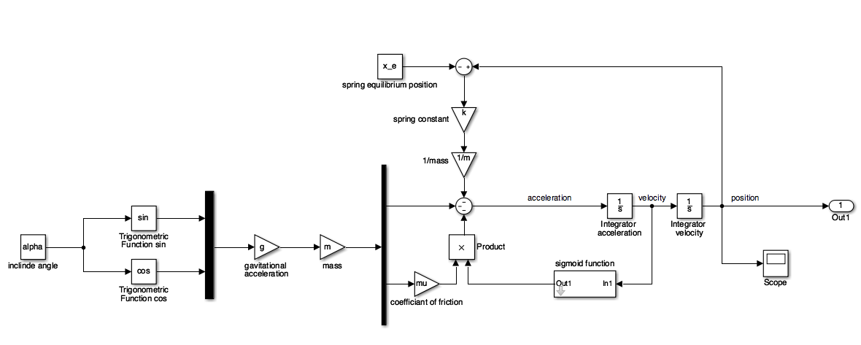

And Sigmoid function as below (growth factor = 20)

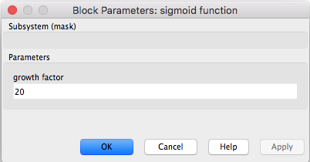

This is Sigmoid Function

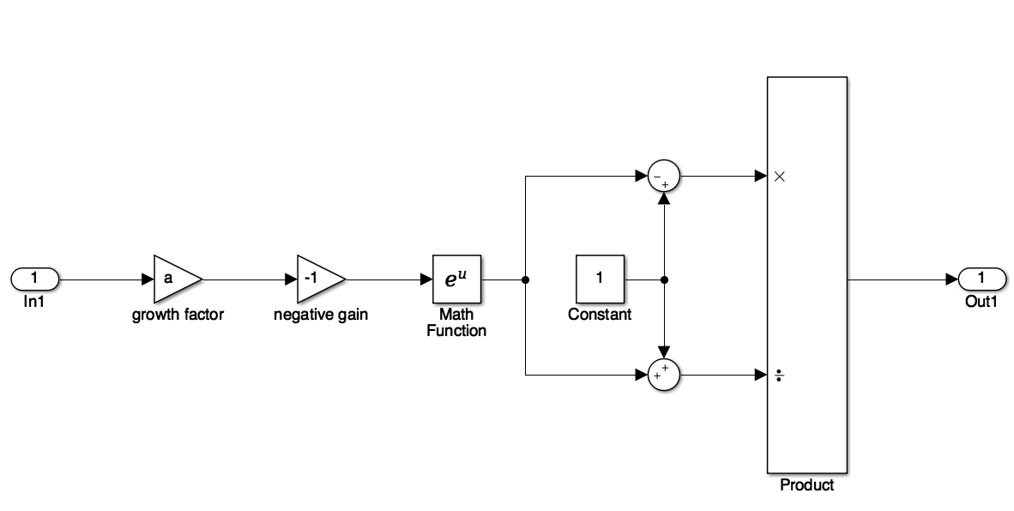

Result shows Dynamic or Y-axis -> position and X- axis -> time

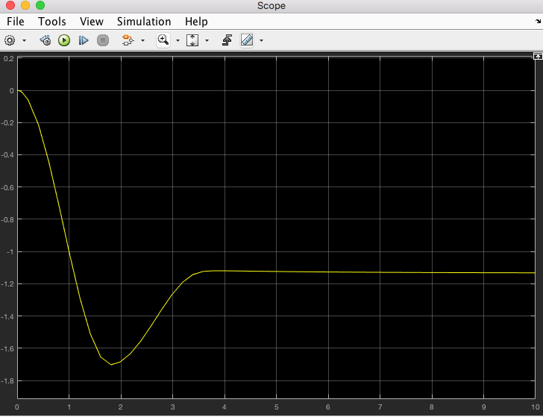

You can use Command Line

>> plot(x_1.Time,x_1.Data)